DQL1
-- TransactionId INTEGER No Unique identifier of a transaction. Can be assigned during data normalization process.
-- TransactionType VARCHAR2(255 BYTE) Yes Possible values: ClaimPayment/CostPayment/Recovery
-- ClaimId VARCHAR2(30 BYTE) Yes Foreign key to "Claims" data set
-- TransactionDate DATE Yes Transaction date
-- UWYear INTEGER Yes Underwriting year related to the transaction.
-- UWMonth INTEGER No Underwriting month related to the transaction.
-- ReinsuranceGroupingId INTEGER Yes Reinsurance grouping id (text in order to accommodate dummies, which names often include letters).
-- TransactionCurrency VARCHAR2(30 BYTE) Yes ISO code (3-letter) of the transaction currency.
-- Amount NUMERIC Yes Amount in transaction currency

define "ClaimId" text 30 .
define "TransactionType" text 15 .
define "ReinsuranceGroupingId" text 20 .
define "TransactionCurrency" text 30 .
define "UWYear" numeric string 4 .
define "UWMonth" numeric string 2 .

for TaahPagRec ;
message current item number .
assign ClaimId := concat (SerieSinistro , NSinistro ) .
assign TransactionType := if (Distinta = "P" , if (CausaleImporto <= 3 , "ClaimPayment" , "CostPayment" ) , "Recovery" ) .
assign UWYear := year(DataContabile) .
assign UWMonth := month(DataContabile) .
assign ReinsuranceGroupingId := blank .
assign TransactionCurrency := "EUR" .

list records
NMandato ;
temp TransactionType ;
temp ClaimId ;
DataContabile ;
temp UWYear ;
temp UWMonth ;
temp ReinsuranceGroupingId ;
temp TransactionCurrency ;
Importo .
end .
export to "V:\Controlling\Minerva\Reports\Minerva_Italy_Transactions.txt" .
TransactionId|TransactionType|ClaimId|TransactionDate|UWYear|UWMonth|ReinsuranceGroupingId|TransactionCurrency|Amount
.items
@f[1,1,12]|@f[1,2,15]|@f[1,3,30]|@f[1,4,10]|@f[1,5,4]|@f[1,6,2]|@f[1,7,20]|@f[1,8,30]|@f[1,9,11]
.end
------------------------------------------------------------------------------------------------------------------------------------------------------------------------------------------
Launched via
MemoExecDQL(DQL1,"","","","","",)
It works
Here the result:
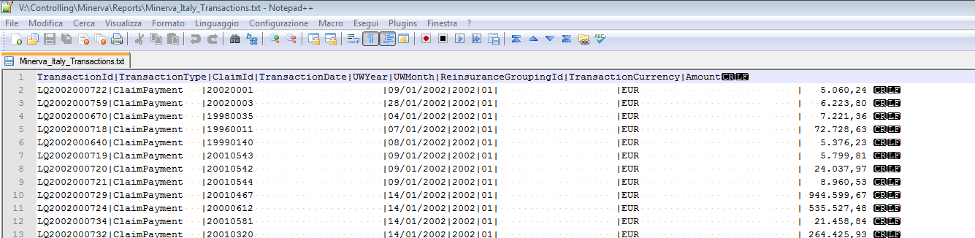

DQL2
define "ReinsuranceGroupingId" text 20 .
define "TransactionCurrency" text 30 .
define "UWYear" numeric string 4 .
define "UWMonth" numeric string 2 .

for TaahPagRec ;
message current item number .
assign ClaimId := concat (SerieSinistro , NSinistro ) .
assign TransactionType := if (Distinta = "P" , if (CausaleImporto <= 3 , "ClaimPayment" , "CostPayment" ) , "Recovery" ) .
assign UWYear := year(DataContabile) .
assign UWMonth := month(DataContabile) .
assign ReinsuranceGroupingId := blank .
assign TransactionCurrency := "EUR" .

list records
NMandato ;
temp TransactionType ;
temp ClaimId ;
DataContabile ;
temp UWYear ;
temp UWMonth ;
temp ReinsuranceGroupingId ;
temp TransactionCurrency ;
Importo .
end .

-----------------------------------------------------------------------------------------------------------
Launched via
MemoExecDQL(DQL2,"","","","","V:\Controlling\Minerva\Reports\Minerva_Test.txt",)
It doesn’t work as expected

Here the result :
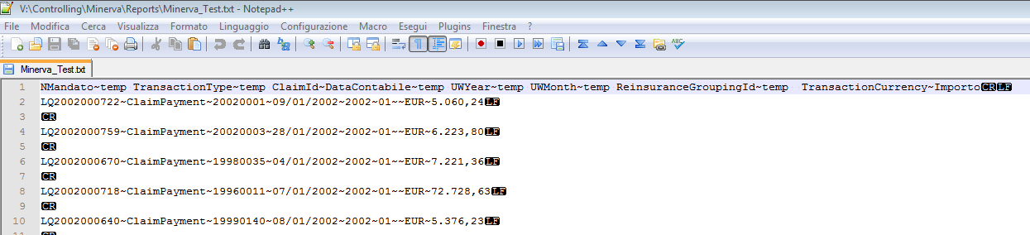

Each records must by ended by CR and LF

